An evaluation of Machine Learning as a mental health tool.
Connor Murphy
School of Design and Informatics
Abertay University
DUNDEE, DD1 1HG, UK

ABSTRACT
Machine learning ML
Machine learning Algorithm MLA
System Useability Survey SUS
Concept:
Over the last Century, the understanding of the importance of a person’s mental health has steadily increased. Despite the creation of institutions and schools of thought based around mental health. For many thought the current level of care is not quite enough. Here in the UK especially the lack of resources and manpower of the NHS is well known. This includes the mental health sector and the number of trained psychiatrists. This project wishes to help resolve this issue by outsourcing minor issues by helping users recognize their current mood. And lead them toward the positive by giving users positive reinforcements and useful advice for general issues.

Aim: To Develop and Evaluate a mental health helper tool using machine learning as a base.

Method: First a dataset for keyboard or keyboard+ mouse interaction with correlation to mood must be found or created. Next, choose an appropriate MLA. This is heavily dependent on the final data set but at its most basic the question the MLA is trying to answer is. “Is this person depressed yes or on” AKA binary classification so K nearest neighbor or similar. Then the MLA would need to be tuned for generality over accuracy since Psychology is not an exact science. However, accuracy and precision recall should all be over 75% to avoid false diagnoses as this could exacerbate problems.

Once the MLA is fully trained and evaluated it will need to be integrated into some form of application for the user to interact with. As this is a tool designed to be a proof of concept it will be a web application designed in Visual Studio. It will be simple and prompt a simulated normal user interaction. Data from this interaction will be fed into the MLA and the answer will cause a predetermined self-help response. In order to properly evaluate the tool using SUS survey, interviews and questionnaires. From these, we can determine if the tool can be used in an everyday setting or as a tool that can be used by professionals.

Results: The most optimal outcome is for users to find the prototype useful backed up by interviews and surveys. The users collaborate that this prototype can be used in daily life. The prototype can be further developed into a web app or browser extension and can be tailored to the specific users’ needs as well as through the MLA learning their interaction patterns.

Keywords
Mental Health, Interaction Patterns, Machine Learning, Classifier algorithms, Health Care

1. INTRODUCTION
In the last five years, the number of people seeking mental health support has increased by upwards of 10% (BMA, n.d) and that’s just in the UK. If that is extrapolated outwards to the rest of the world that is hundreds of millions of people. Here in the UK, the NHS is known for its lack of resources including the mental health sector. Meaning a lack of trained mental health experts, psychiatrists, equipment, beds and aftercare. There is a clear gap between supply and demand, however, this is people’s lives getting disrupted.
The use of new technologies is paramount in the medical world. Finding new treatments reduces risk during surgery and the like. As such Machine Learning has been used in hospitals for years to help make diagnoses. In fact, one of the most famous machine learning data sets is used to detect heart defects using a patient’s medical data. So what if machine learning can be similarly used to determine a mental health diagnosis? If a tool could be made to help mental health professionals care for patients more easily that opens them up to help more patients. Helping to solve the supply issue.

Machine learning works by feeding a computer data so it can find patterns. “Unsupervised” if we leave the computer to find the patterns themselves usually finding connections humans could never have thought to make. There is also “Supervised” where we along with the data give a label stating what the data results in. This way the ML can generally predict what group or result the data will lead to. However, this process requires torment amounts of data. With one line of data having upward of 5 values associated with them. With most MLA needing hundreds of lines of data or data sets to function efficiently.

However, in this context, this is a good thing. Since MLA are only as accurate as the data they are trained on. This means that the proof-of-concept tool put forward by this document could be further developed to be specified to the user. If the tool takes the user's data through continual use the MLA can be trained on data specific to the user. Similar to how targeted ads work but this will be much more useful. Since everyone’s brain works slightly differently a tool trained on for example. Someone with anxiety could be much more accurate in detecting stress from anxiety and give appropriately specific advice such as breathing exercises. With a tool like this that can “understand” a user through continual exposure and give day-to-day advice. Hopefully, psychiatrists will receive fewer bookings for smaller problems and open themselves up to help more people.

2. BACKGROUND
There have already been some studies on how mood can effect user interaction and using ML to detect said moods through said interactions.
2.1 Key Stroke dynamics and mood
Firstly, there was a paper written in May 2020 by Claudia Vessel of the University of Chicago for the Journal of the American Medical Informatics Association. In this paper, Claudia and others attempted to “determine the feasibility of smartphone-derived real-world keyboard metadata to serve as digital biomarkers of mood.” Aka using a phone keyboard and user's interaction with said keyboard to develop a system that can accurately determine the user's mood. Exactly what this project is based on. To collect their data, they used a feely available phone app that replaced the normal phone keyboard with one that collects keyboard metadata but not what is typed keeping the subject’s privacy. This method of data collection or something similar could be used in this project. Data from “>14 million keypresses from 250 users” were sorted by participant's age, mental state, and time of day the interaction took place.
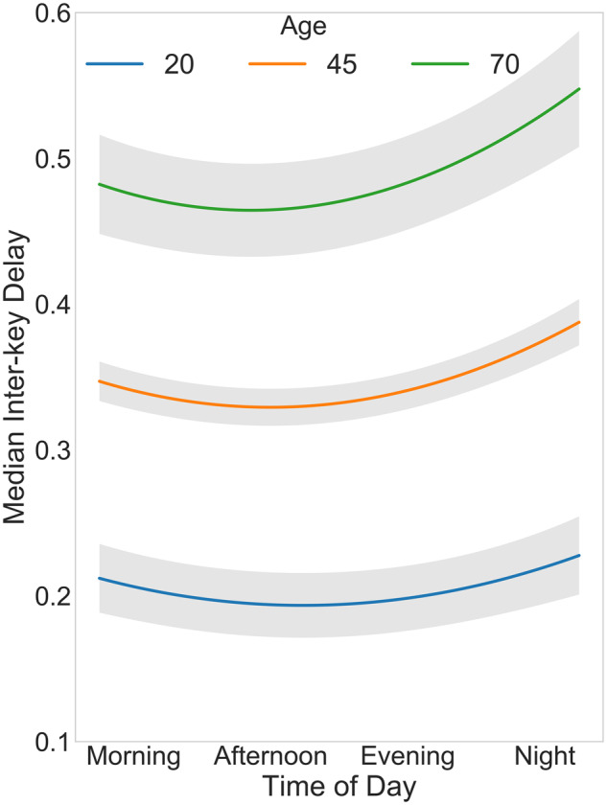
Figure 1 – Graph from paper showing the delay between key presses and age range.

The paper's results show “that more severe depression relates to more variable typing speed.” (Vessel, 28 May 2020) but also found that “the effects of aging did not affect the relationship” (Vessel, 28 May 2020). One thing of note, however, is that all the diagnoses used in this paper are self-diagnosed and not officially verified. However other papers and blogs do verify the results of this paper. Some of which will be discussed later in this proposal. The results from this paper show that there is data that an MLA could use to determine mood as there is a notable difference between Happy and sad no matter the age of the user. This project, however, believes that data based on mechanical keyboards would be of more benefit. As most people use a laptop or desktop PC for large parts of the day. Hence any ML tool would have to be trained off of a mechanical keyboard, not a digital keyboard. This project believes that the results found in this paper will mirror results from mechanical keyboards as the interactions for both are identical.

2.2 Machine Learning in Mental Health
The topic of ML and its use in mental health is a well-developed subject. With many papers and journals written on the subject. From the viewpoint of computer scientists through to medical professionals. One paper that collates and reviews a number of these papers and such is. Machine Learning in Mental Health. By Anja Thieme. Thieme focused their findings on What MLA was used, how the ML training data was collected, what ethical precautions where taken, if there were any limitations of projects, what practical applications were made, and the trend of new papers published for the topic see below.
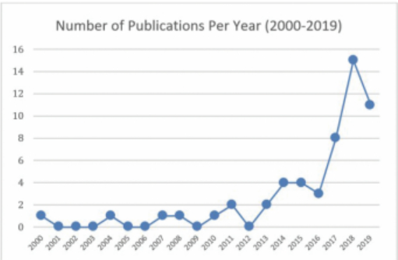 Figure 2 – Graph from paper showing the growth of papers in the topic over the last decade.

All these findings will be very useful to this project’s development and methodology. Some of the findings that this project will consider are.

Ethical concerns
There is one main concern raised by Thieme. First using an MLA to diagnose someone. Due to ML's nature of possibly being wrong in its answers. It cannot be solely used to diagnose and treat. It could lead to exacerbating the problem. To combat this the test subjects of this project will be clearly told that the results should be used as a guide. As well as staying in a general mood.

Possible limitations
The biggest problem faced by many projects was found to be acquiring large high-quality data. Mainly because of the aforementioned ethical issues and lack of properly verified labeled data. e.g., happy, sad, angry. This extends to getting actionable data for specific illnesses. This is why this project will focus on getting a correct mood reading and reinforcing a positive mental attitude.

Practical applications
Thieme’s study found that despite the majority of artifacts were made and tested. “The majority of models are rarely tested for use in clinical environments” This is where this project will contribute towards. By developing an MLA and testing it in real-world environments for usability and effectiveness. Something found lacking by Thieme’s review.
2.3 Detecting Depression Symptoms
One paper that closely resembles this project in theory and practice is "Detecting Depression Symptoms in Higher Education Students Using Multimodal Social Media Data". (Mann, Paes and Matsushima, 2020) So the aim of Mann's paper was to prove that the level of a person's depression could be predicted using ML using data from social media posts. Now the data used in Mann's paper was not user interaction from a keyboard. however, this paper believes that the method used by Mann will be useful when implementing this project's MLA, in this paper Paulo Mann and others used a collaboration of three different MLA's to determine levels of severe depression. The data Mann used came from social media posts, specifically Instagram. The data was split into text, images, text and images. These were then fed into three Deep-learning and three feature-engineered MLA's. This is more complex than what this project will use but the methodology used is similar to what this project will need to use. Mann found that "deep multimodal classifier is helpful in the task of screening depression" and that feature-engineered models were "competitive" (Mann, Paes and Matsushima, 2020). For this project to make a useable mental health tool, however deep learning models are not viable. This is due to an everyday tool needing to be quick and simple to use. So deep learning with its high computational cost will slow down the tool. Hence a standard MLA with well-engineered features will be of more use to this project. Mann's paper shows that ML can be practically applied and that this project can do the same even if the types of data used are different. If the principle in this case user keyboard interaction showing mood is scientifically sound. This project can make a viable application. If that application can be used in a professional environment and help provide help to those who need it. Needs to be proven by this project.

3. METHOD
There are two main aspects to the practical portion of this project. Designing a web application around an MLA trained on data taken from keyboard interactions. Also, evaluate said web application for its usability and effectiveness. All MLA's need large amounts of good data to train on. however as previously stated by Thieme this could be a problem, due to this project's time frame this project believes that a pre-developed data set should be used. preferably one that is labelled to a mood. this way the artifact can avoid being specialised to a specific mental illness staying generalized to people's mood and positively reinforcing good moods. Since this project will probably be using a labelled data set a supervised MLA will be needed. The algorithm used is highly dependent on the data set but considering the prerequisites laid out this project will most likely use a random forest algorithm. This is because Random Forest can reduce overfitting of the data increasing accuracy also random forest can handle large data sets well. Random Forest also Thieme’s paper also reviewed several papers that used random forest as their MLA which showed good, verified results that this project hopes to utilise. The MLA will be tuned and evaluated until satisfactory accuracy and f scores are obtained the project will continue.

The aim of this project is to evaluate the use of ML as a mental health tool. As such the artifact of this project only needs to be developed enough to prove the viability of ML as a tool. Due to this proof-of-concept nature, the MLA will be worked into a Windows Web Application. A fully developed version of this program could be a Chrome extension for casual use. perhaps developed into a function of a word processor to help with productivity but for the purposes of this project, a basic application will do. The application will prompt a user interaction with the keyboard and with a rudimental keylogger take that data and feed it to the MLA for a prediction. Based on the result a predetermined positive mental health message or techniques will be displayed.

To properly evaluate the web application a suitable testing environment will be needed such as a library or café an everyday location. here the tester will be asked their current emotional state. then prompted to use the web application for the whole process. logging the MLA's result this can be used further to evaluate the MLA in a real-life scenario. This method could then be repeated with changes in the environment to try and cause different emotional states to fully test the system. them after the testing session an interview and SUS survey will be carried out to find if the testers would use the tool in everyday life. This method will be repeated for 30 or so participants in order to get a representative range of user perspectives. the project could also consult mental health professionals and get their opinion on if they would recommend the tool.

4. SUMMARY
ML is a tool that is used in many areas, not just in medicine. It has just not been used to its full potential in respect to a mental health support tool. As you have just read there is already a president backed up by peer reviewed data for ML to detect mood through many user interactions. It is just that this research has not been used to develop a practical and useful application. That is what this project hopes to achieve. A support tool that will help people with mental health issues regulate and understand their emotions. As well as lessening the load on mental help support organizations. Also, this project hopes that a more experienced specialist can take this proof-of-concept tool and further develop it to be tuned to specific mental health problems such as chronic depression or Alzheimer’s (Griffin, 2023) That way more people can get the right help that they need and not the help from an amateur in the subject.

5. REFERENCES
Griffin, J. (2023). Blog - Typing Patterns as Biomarkers: Digital Phenotyping in Mental Health Assessment. [online] Fleksy. Available at: https://www.fleksy.com/blog/typing-patterns-as-biomarkers-digital-phenotyping-in-mental-health-assessment/#:~:text=The%20researchers%20found%20that%20individuals[Accessed 07 Oct. 2023].

Mann, P., Paes, A. and Matsushima, E.H. (2020). See and Read: Detecting Depression Symptoms in Higher Education Students Using Multimodal Social Media Data. Proceedings of the International AAAI Conference on Web and Social Media, 14, pp.440–451. doi: https://doi.org/10.1609/icwsm.v14i1.7313.[Accessed 11 Oct. 2023].

The British Medical Association is the trade union and professional body for doctors in the UK. (n.d.). Mental health pressures data analysis. [online] Available at: https://www.bma.org.uk/advice-and-support/nhs-delivery-and-workforce/pressures/mental-health-pressures-data-analysis#:~:text=Between%202017%20and%202022%2C%20rates.[Accessed 03 Oct. 2023].

‌Thieme, A., Belgrave, D. and Doherty, G. (2020). Machine Learning in Mental Health. ACM Transactions on Computer-Human Interaction, [online] 27(5), pp.1–53. doi: https://doi.org/10.1145/3398069.[Accessed 03 Oct. 2023].

‌Vesel, C. (2020). Effects of mood and aging on keystroke dynamics metadata and their diurnal patterns in a large open-science sample: A BiAffect iOS study. [online] National Library of Medicine. Available at: https://www.ncbi.nlm.nih.gov/pmc/articles/PMC7647317/[Accessed 10 Oct. 2023].

